- Celestial Forest presents…

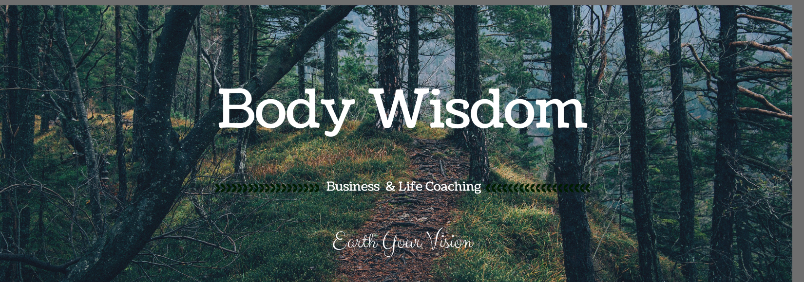Body Wisdom Energy Healing-Module 2 Tracking Sheetack!

Please log your note below and return to me via email to three-feathers@hotmail.com for certification.

Class 1

Class 2

Class 3

Class 4

Class 5

Class 6

