Celestial Forest presents…

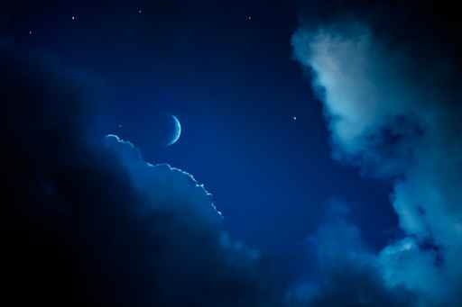
The StarMaiden Priestess Process™

Discover a Deeper Direct Relationship to the Sacred

StarMaiden Priestess Suggested Guidelines & Tools

Creating Sacred Space for Each Call

If you are utilizing the on-line feature of this program, there are a couple things you can do to support your experience before each call or listening to the replay.

If possible find a quiet place to listen to the call free from distractions.

Have some paper handy or your journal for the Process.

Create sacred space and/or a little altar by placing some fresh flowers or even some lovely leaves or a potted plant near you. Having a bowl and/or glass of water nearby. Light a candle if you feel called to do so. Place any of your favorite sacred objects that you want in the area.

The more you create sacred space for yourself with each all the more powerfully the energy will work with you.

Give yourself a little tie after each call or replay for the energy to settle in and you to have a complete experience before transitioning to other activities.

You can find the link for the webcast in your email each week, on the Facebook page and in the classroom: https://www.kath-daugherty.com/copy-of-high-priestess-classroom

Priestess Process Tools

Connecting to your inner process by journaling throughout the process will strengthen your ability to access your inner wisdom and guidance.

Journal Writing Guidelines by Nicole Christine

Journal writing is an exploration of one’s inner landscape that potentially takes the writer into the depths of the subconscious and the expanse of the superconscious. Through it, an individual can chip away at her or his sense of limitation and burst through into fields of limitless potential. It is an opportunity to clear out mental and emotional debris, to source the vast pools of mental and emotional intelligence, and to anchor life-affirming visions, dreams, realities. It is an opportunity to develop your personal “how to” manual for all areas of your life, to enhance your creative expression, and to enliven your process of ever-expanding consciousness and self-discovery.

Guidelines:

Situate yourself comfortably in your favorite place.

Write on unlined colored paper with colored pens or pencils.

Write for yourself.

Let go of concerns about spelling, grammar-even legibility.

Date your entries.

Draw, doodle, scribble. Write sideways, upside down, in circles and spirals.

…THEN WHAT?

Read what you have written! Sit with it. Let it speak to you. Receive what you have written. Journaling is much more than a writing activity. By silently reading what you have committed to written form, you will greatly strengthen your self-awareness.

Next, read your entry aloud. Written words are congealed energy that is empowered, magnified, and allowed to move, when given a voice. If you have written about a challenging circumstance, you are likely to experience a cathartic release as you write. By reading the words aloud, the release or insights are maximized and you allow trapped energy to move, to be liberated, and your life force to flow unrestrictedly.

Releasing creates openings in the emotional body that leads to greater access of one’s innate knowing. Fill these spaces with beauty, self-love, and appreciation. Take a nurturing bath or a walk in nature, play inspiring music, dance. Be gentle with yourself. Moving dark-night-of-the-soul energies is liberating. Moving stagnant, unexpressed emotions of joy, love, and compassion is exhilarating. Through journaling, you may discover that your deepest pain is due more to the suppression of love and creativity than to the suppression of anger, fear, hate, or resentment.

Dance Activations

Dance is a primary activation tool for the priestess process because it engages all the elemental realms and creates full body temple access to the Divine.

Music

I love the music of James Asher, Feet in the Soil and Feet in the Soil 2. You will be able to find the link to purchase this music along with others we use in class, on the classroom page.

Tracking Your Progress

In order to receive your certificate of completion, you need to send in our completed tracking form. Please fill it out for each module in order to track your progress and completion.

Supplemental Reading

Additional books can expand your experience and several can be found on the classroom page. They are helpful but not mandatory.

Holding the container for your own process:

The StarMaiden Priest/ess Process is for mature men and women ready to step into a fuller connection to their sacred power and wisdom in the world. This process is sometimes therapeutic, but is not therapy. Each person is responsible for her or his own process.

